深圳大学考试答题纸
(以论文、报告等形式考核专用)
二○二五～二○二六 学年度第 二 学期
课程编号 | 1502850001 |  | 课程名称 |  | 互联网编程 |  | 主讲教师 |  | Basker George | 评分
学号 | 2024150171 |  | 姓名 | 陈靖果 |  | 专业年级 |  | 计算机科学与技术(创新班)
学号 | 2024150138 |  | 姓名 | 李培鑫 |  | 专业年级 |  | 计算机科学与技术(创新班)
学号 | 2024150066 |  | 姓名 | 苏泽铭 |  | 专业年级 |  | 计算机科学与技术(创新班)
学号 | 2024150126 |  | 姓名 | 何展明 |  | 专业年级 |  | 软件工程
教师评语：The mark obtained for different categories as per the grading policy are as follows
序号 | 评分点 （分值） | 成绩
1 | Correct implementation of socket communication (TCP/UDP) (10 pts).
2 | Proper handling of multithreading/NIO (10 pts).
3 | Security features (SSL, password hashing) (10 pts).
4 | HTTP protocol compliance (if applicable) (10 pts).
5 | Code Structure (10 pts)
6 | User Experience (10 pts)
7 | Innovation (10 pts)
8 | Report (30)
合计 100



Basker George
05 JULY 2026

题目 |  | Multi-Threaded Client-Server Chat Application with Encryption
Experimental Procedures

- NIO-Based TCP Communication and Multi-Client Concurrent Processing

Clients establish TCP connections via java.net.Socket and conduct line-based text communication using \n as the message delimiter.
The server adopts the Java NIO architecture consisting of Selector, ServerSocketChannel and SocketChannel. A single Selector thread listens for the OP_ACCEPT, OP_READ and OP_WRITE events of all channels with non-blocking processing. Once messages arrive, MessageCodec decodes data from the ByteBuffer by splitting on \n, then dispatches the decoded messages asynchronously to a FixedThreadPool (thread count equal to the number of CPU cores) for routing, preventing blocking of the I/O thread. Write operations are buffered with a ConcurrentLinkedQueue; if data cannot be fully written in one attempt, the OP_WRITE event is registered to resume writing upon the next trigger.

Selector Event Loop & Event Dispatching
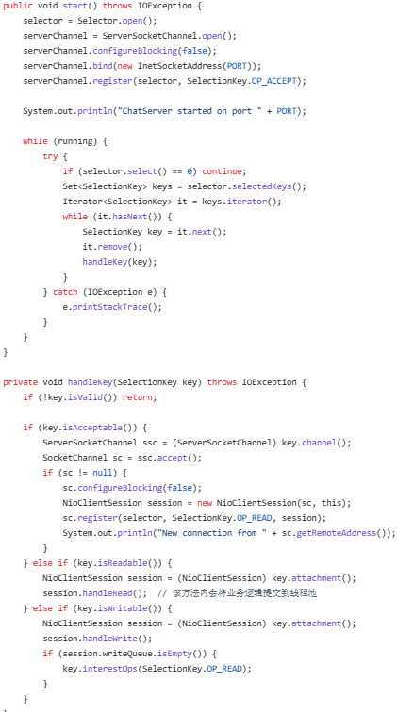
The start() method initializes the Selector, binds the ServerSocketChannel to port 9000 in non-blocking mode and registers the OP_ACCEPT interest; the main loop executes selector.select() and iterates over the selected keys. The `handleKey()` method dispatches logic based on ACCEPT, READ and WRITE events: it creates an NioClientSession when accepting new connections, reads incoming data, and flushes the write queue.

Read/Write of NIO Session & Submission to Business Thread Pool
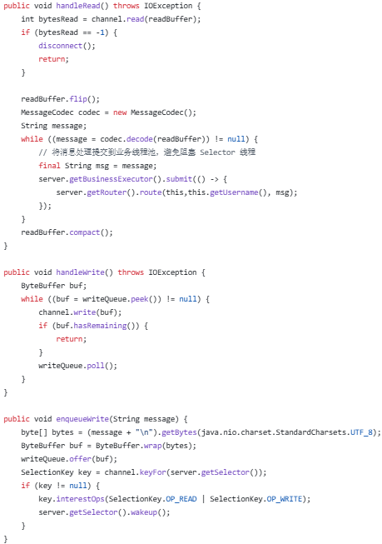
handleRead(): invoke channel.read(), decode data via MessageCodec.decode(), then submit the decoded message to the business thread pool by calling server.getBusinessExecutor().submit();
handleWrite(): fetch ByteBuffer instances from ConcurrentLinkedQueue and write them to the channel;
enqueueWrite(): append the newline character \n, wrap the data into a ByteBuffer and enqueue it, register the OP_WRITE interest and wake up the selector.

MessageCodec: decode messages split by line breaks
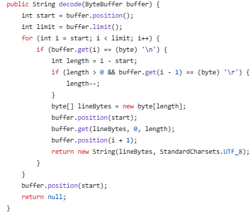
Iterate over the ByteBuffer to search for \n (compatible with \r\n), extract complete lines, decode them with UTF-8 and return the result. If no line terminator is found, reset the buffer position and return null (waiting for incomplete packet data).

- User Authentication & SHA-256 with Salt Password Hashing

Clients send protocol messages in the format:
LOGIN|username||password or REGISTER|username||password.
The server-side MessageRouter invokes UserManager for processing. Password storage adopts the SHA-256 plus random salt scheme: generate a 16-byte salt via SecureRandom, compute SHA-256(salt + password), then store the pair in users.dat as salt:hash. During verification, extract the stored salt, recalculate the hash, and perform constant-time comparison to mitigate timing attacks.

SHA-256 Hashing with Salt and Constant-Time Verification
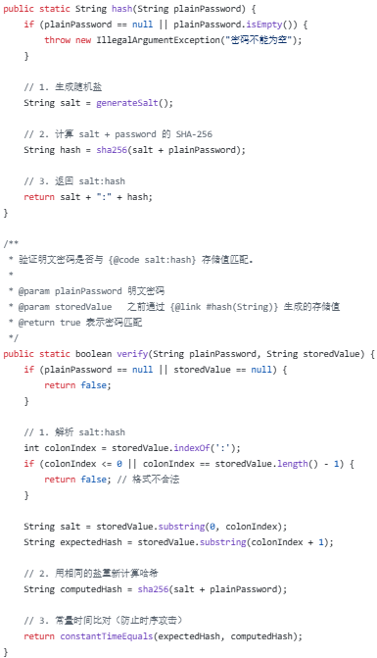
hash(): generate a random salt, compute the SHA-256 digest, and return the string formatted as salt:hash;
verify(): parse the stored salt value, recalculate the hash, and invoke constantTimeEquals() to perform bytewise XOR comparison for consistent execution duration.

User Registration & Login + Data Persistence
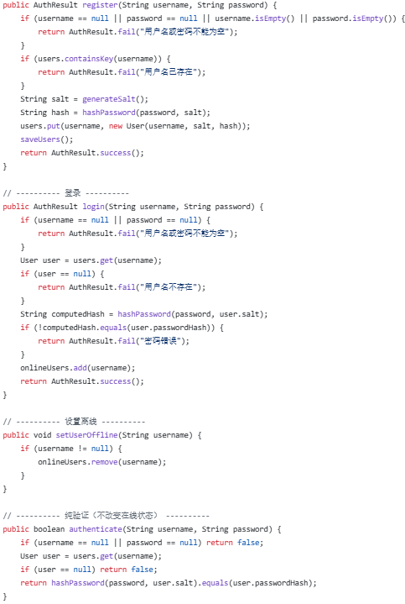
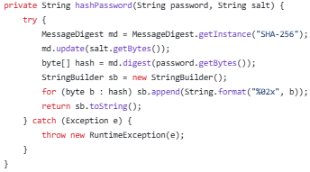
register(): Check username uniqueness, generate credential, store in ConcurrentHashMap, then persist data to users.dat via saveUsers();
login(): Recalculate hash with stored salt for comparison;
authenticate(): Perform authentication only without modifying online status;
hashPassword(): Implemented by MessageDigest.getInstance("SHA-256").

Authentication Message Routing
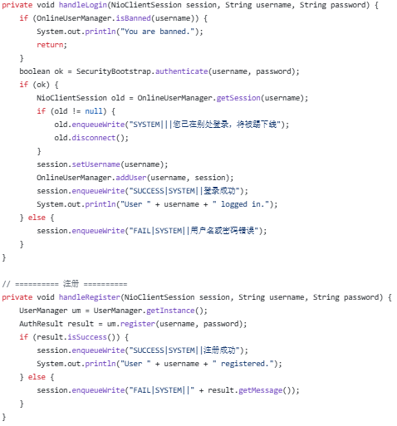
handleLogin(): Check ban status, call SecurityBootstrap.authenticate(), kick out the old session, invoke OnlineUserManager.addUser(), and reply with SUCCESS;
handleRegister(): Call UserManager.register().

- End-to-End Encryption with SSL/TLS

Load certificates from the JKS keystore via SSLContextBuilder, create an SSLContext, and generate an SSLServerSocketFactory. Toggle between plaintext and encrypted modes through the useSSL switch; TLSv1.2 is used by default.
Note: The current NIO implementation relies on ServerSocketChannel. SSL encryption and decryption are implemented at the channel layer using SSLEngine. The SSLContextBuilder provides a fully implemented certificate management infrastructure.

SSL Context Initialization (JKS Keystore → SSLContext)
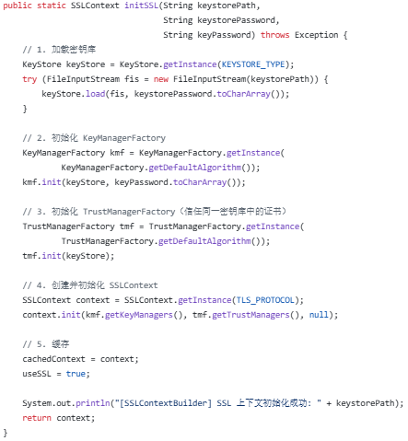
Load keystore via KeyStore.getInstance("JKS"); use KeyManagerFactory to manage private key certificates and TrustManagerFactory to manage trusted certificates; initialize and cache SSLContext.getInstance("TLSv1.2").

Factory Method for SSLServerSocket
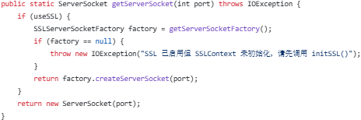
getServerSocket(port): Returns an SSLServerSocket or a standard ServerSocket depending on the useSSL flag.

- UDP Broadcast Messages

A standalone UDPBroadcastServer thread listens on UDP port 9999. Upon receiving a UDP datagram, it invokes ChatServer.broadcast() to forward the message to all online TCP clients, enabling cross-protocol announcement broadcasting.

UDP Reception & Forwarding to TCP Broadcast
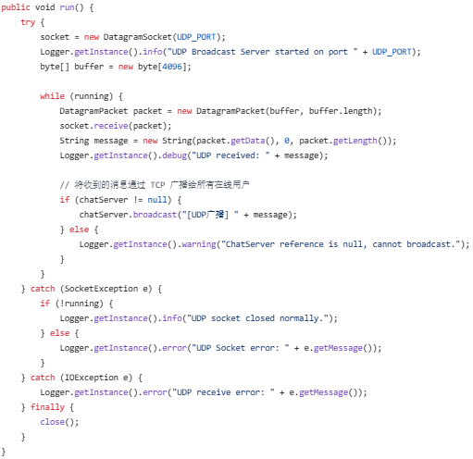
Initialize DatagramSocket bound to port 9999; block on socket.receive(packet) to receive datagrams, decode the payload into a string, then call chatServer.broadcast("[UDP Broadcast] " + message) to forward the content to all online TCP clients. This thread is started at lines 35–37 in ExtensionManager.java.

- HTTP File Sharing and File Transfer

A dual-channel design is adopted:
HTTP Channel: An HttpServer listens on port 8080, exposing POST /upload and GET /download endpoints. Clients communicate via HttpURLConnection, and uploaded files are stored under the server_files/ directory.
TCP Socket Channel: Uses FILE_UPLOAD protocol messages. Files are encoded in Base64 and transmitted over Socket connections; the server decodes and persists the files, then broadcasts the downloadable link to all clients.

HTTP File Server Startup & Upload/Download Handler
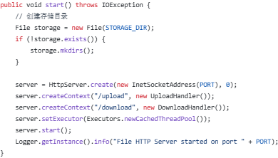
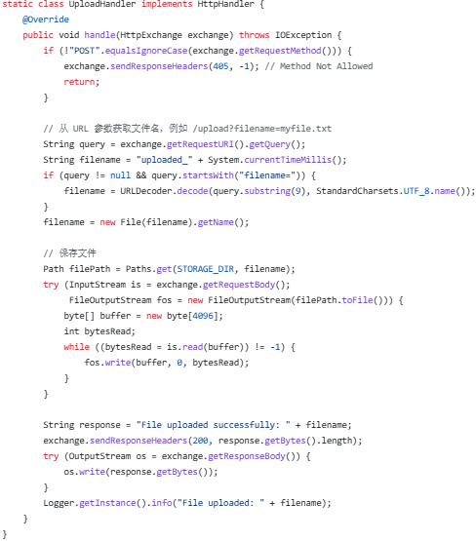
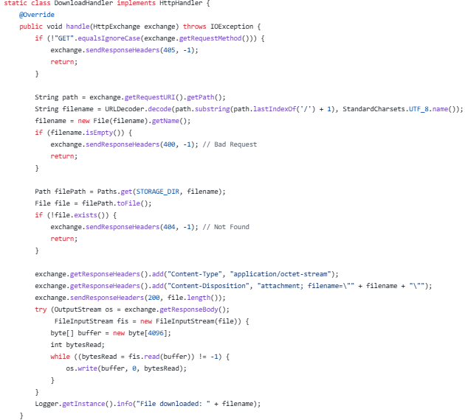
HttpServer.create(8080) → register /upload and /download contexts with a cached thread pool;
UploadHandler: Validate POST requests, extract filename from URL query
parameter ?filename=xxx, write file stream into the server_files/ directory;
DownloadHandler: Validate GET requests, set response header Content-Disposition: attachment, output file via stream.
HTTP Client File Upload
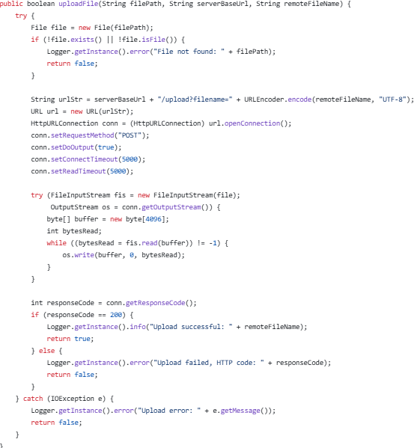
Construct the URL as "/upload?filename=" + URLEncoder.encode(...), invoke url.openConnection() to obtain an HttpURLConnection, configure the connection as POST and enable doOutput, read local file content via FileInputStream, and write data to the request body through getOutputStream().

TCP Socket File Upload — Client Transmission & Server Reception
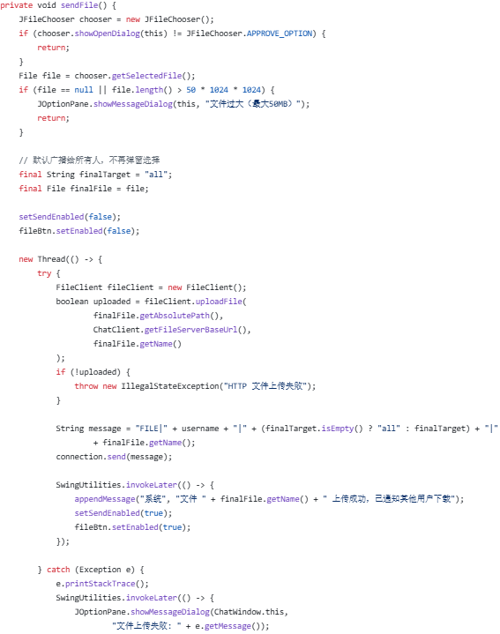
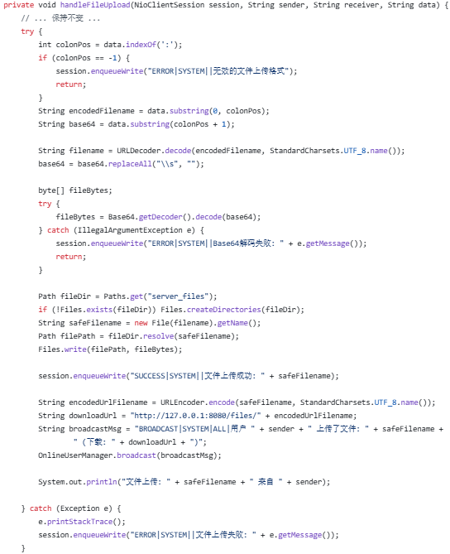
Client-side sendFile(): Select a file via JFileChooser, verify the file size does not exceed 50 MB, encode the file content with Base64, then send the message formatted as FILE_UPLOAD|username|all|filename:base64.
Server-side handleFileUpload(): Parse the filename:base64 payload, decode the Base64 data, write the file with Files.write(), and broadcast the download link to all users.

- Client GUI and Message Sending & Receiving
(Private Chat / Group Chat / Online User List)

Multi-window Swing architecture: LoginFrame leads to ChatWindow (group chat) and PrivateChatWindow (private chat). ClientGUI.onMessage() parses and dispatches messages following the TYPE|sender|receiver|content protocol format.
Group chat uses the BROADCAST message type; the server calls groupBroadcast() to forward messages to all users except the sender.
Private chat uses the PRIVATE message type; the server calls sendToUser() for point-to-point delivery.
The /list command queries all online users.

Main Chat Window UI Initialization & Group Message Sending
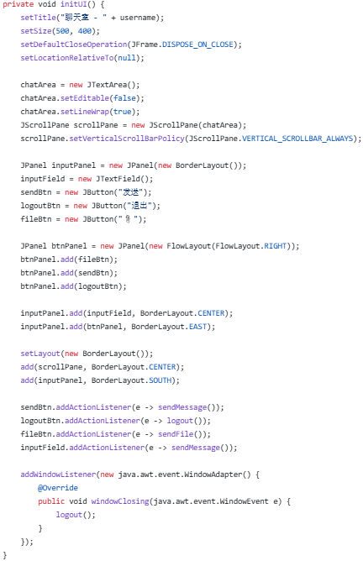
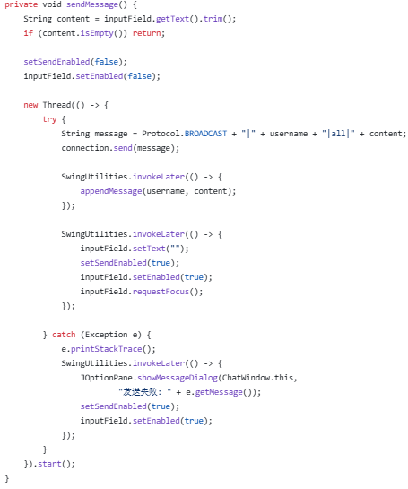
BorderLayout layout: read-only JTextArea at center, JTextField at bottom, plus Send, Exit and attachment clip buttons.
sendMessage(): construct and send message in format BROADCAST|username|all|content, append message content to local display.

Private Chat Window Message Sending & Receiving
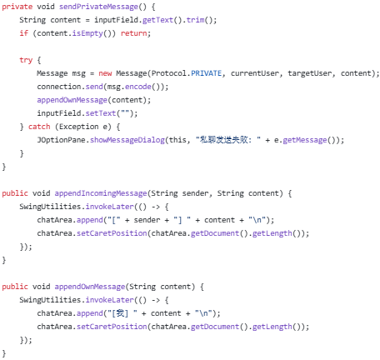
sendPrivateMessage(): Construct and send message formatted as PRIVATE|currentUser|targetUser|content;
appendIncomingMessage() / appendOwnMessage(): Append messages to chat panel via SwingUtilities.

Message Dispatch Controller
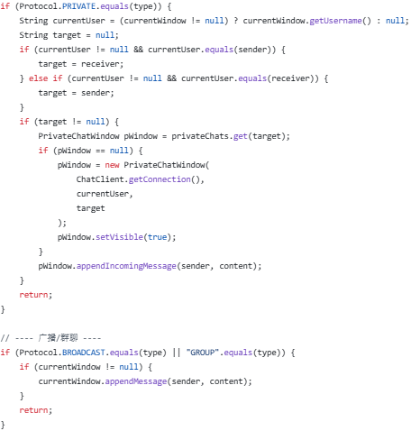
Parse protocol messages:
PRIVATE type: create or locate the corresponding private chat window and append the message;
BROADCAST/GROUP type: append the message to the main chat window.

Server-side Private & Group Chat Routing
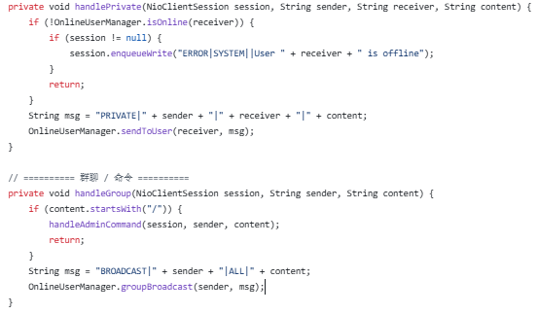
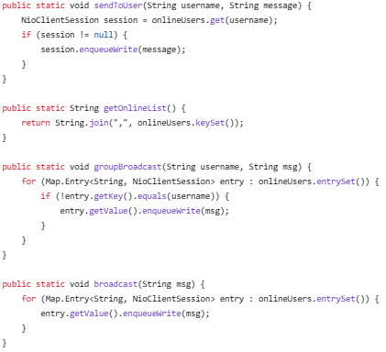
handlePrivate(): Check if target user is online, then deliver message point-to-point via sendToUser();
handleGroup(): Invoke groupBroadcast() to broadcast to all users except the message sender.
In OnlineUserManager:
sendToUser(): enqueue messages asynchronously in non-blocking mode by calling enqueueWrite();
groupBroadcast(): iterate over all online users and skip the sender;
broadcast(): send message to every online user.

Online User List
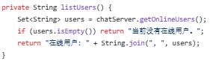
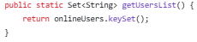
listUsers(): Call getOnlineUsers() to retrieve the key set of the ConcurrentHashMap, concatenate keys with commas and return the result.

- Server-Side User Session Management & Administrator Commands

OnlineUserManager maintains session mappings via ConcurrentHashMap<String, NioClientSession>, handling login, registration and disconnection cleanup. Multi-login detection kicks out the old session when a new connection from the same user arrives.
AdminCommandHandler intercepts commands prefixed with slash /. Users with username admin or root are granted administrator privileges.
Commands /help, /tell and /download require no permissions; /kick, /ban, /unban, /list, /broadcast and /shutdown are restricted to administrators only.

Session Management + User Kicking / Banning
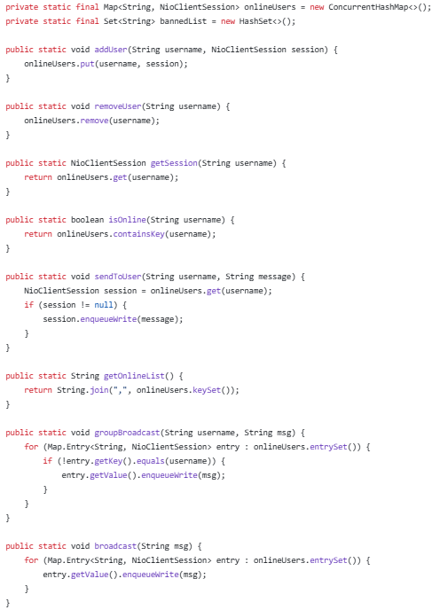
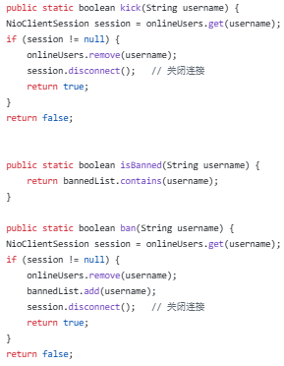
Usernames are mapped to NioSession instances and stored in a ConcurrentHashMap; exposed methods include addUser(), removeUser(), sendToUser(), groupBroadcast() and broadcast().
kick(): Remove the entry from the map and close the channel via disconnect();
ban(): Additionally add the target user to bannedList.

Admin Command Handler
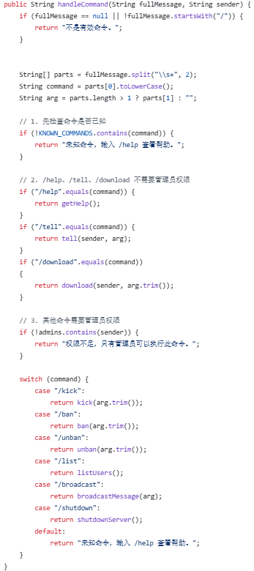
Split commands and arguments, validate supported command types. Commands /help, /tell and /download require no privileges; all other commands verify admin permissions before execution. Dispatch logic via switch-case for /kick, /ban, /unban, /list, /broadcast and /shutdown.

- Server Activity Logging

A singleton Logger supporting four log levels: INFO, WARNING, ERROR and DEBUG. Dual output channels are provided: console output via System.out.println, and persistent file output to logs/app-yyyy-MM-dd.log. The file writer uses append mode with daily log rolling. Each log entry contains a millisecond-precision timestamp.

Full Logger Implementation
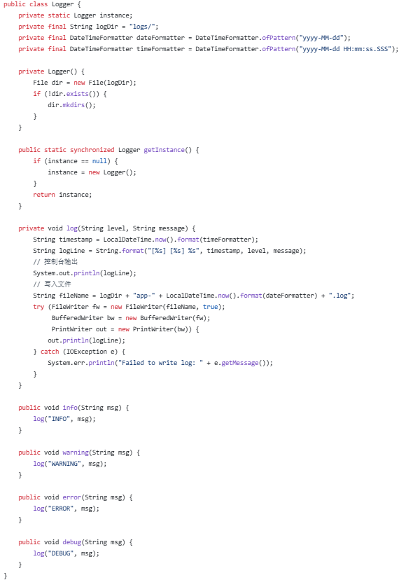
Singleton pattern → generate millisecond timestamp via LocalDateTime.now() → format log entry as [timestamp] [level] message → print to console and write to logs/app-yyyy-MM-dd.log daily by date → four public methods for INFO, WARNING, ERROR and DEBUG levels.

- IPv6 Compatibility and DNS Resolution

Call InetAddress.getAllByName(host) to resolve all IPv4 and IPv6 addresses in one batch, iterate and attempt connections sequentially, return upon the first successful connection. Literal IPv6 addresses are wrapped in square brackets (e.g. [::1]) within URLs to comply with standard formatting rules.

DNS Resolution + Dual-Stack IPv4/IPv6 Connection
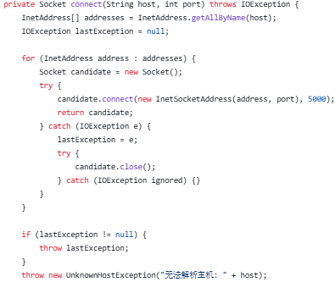
Call InetAddress.getAllByName(host) to retrieve all IP addresses, iterate through each entry to create InetSocketAddress(address, port) and attempt a connection with a 5-second timeout. Return the first successfully connected address; throw UnknownHostException if all attempts fail.

IPv6 URL Format Handling
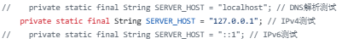
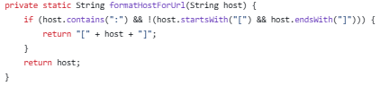
SERVER_HOST supports optional values: localhost (DNS), 127.0.0.1 (IPv4), or ::1 (IPv6);
formatHostForUrl(): Wrap IPv6 addresses with square brackets (e.g. [::1]) to produce valid URLs.

Experimental Results
- Start the server:
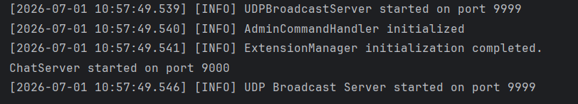

- Start the clients (open the GUI automatically as follow):
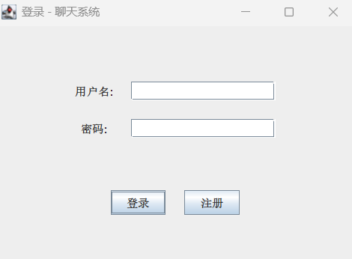

- Login the administrator account:
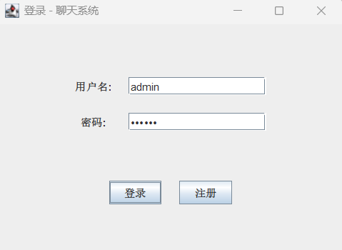

- Register a new normal account:
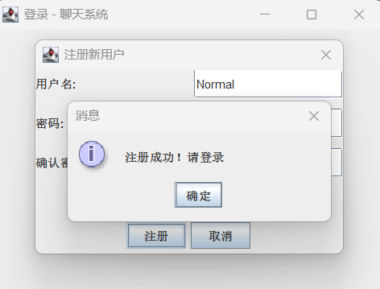

- Test group messages sending:
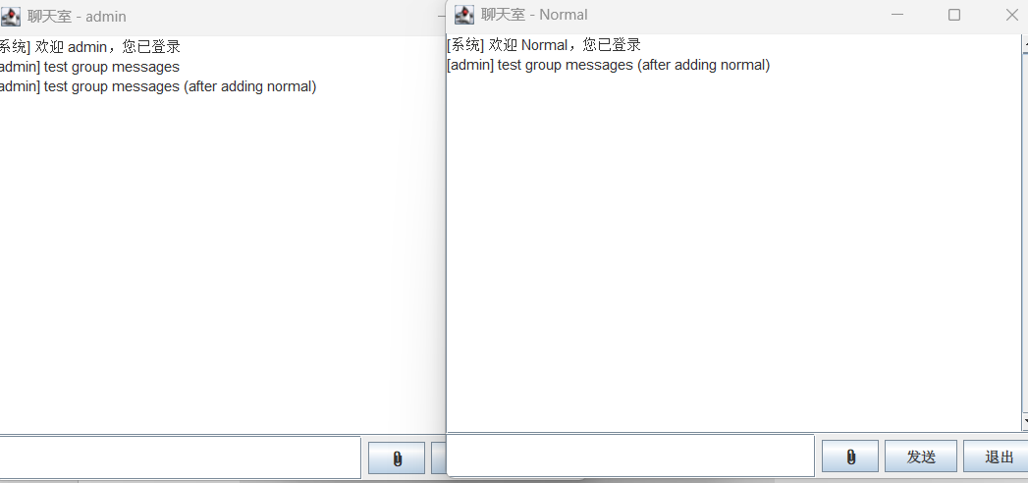

- Test file upload & download:
(uploaded files are stored in the /server_files folder)
(downloaded files are stored in the /downloads folder)
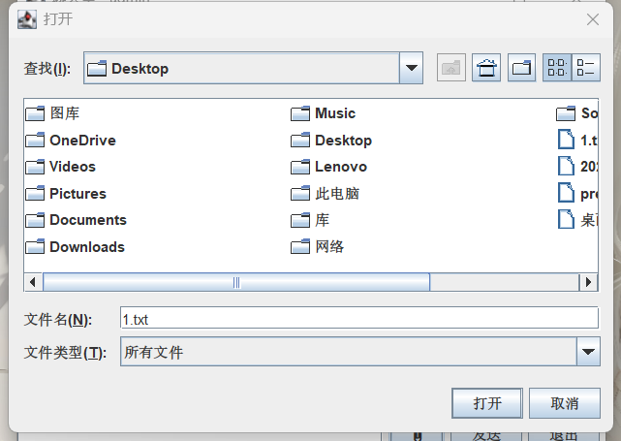
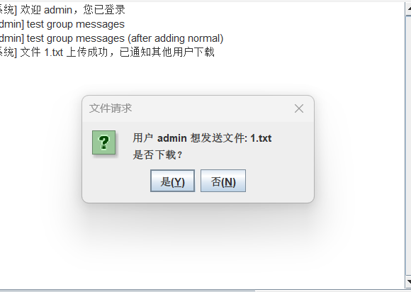
We can also use the /download command to download a specific file:
e.g. /download 2.txt

/server_files:
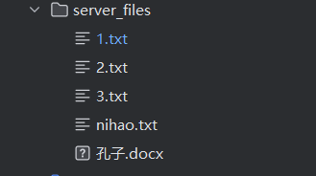

/downloads:
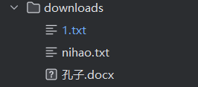

- Test private messages sending:
(using command: /tell <username> <message>)
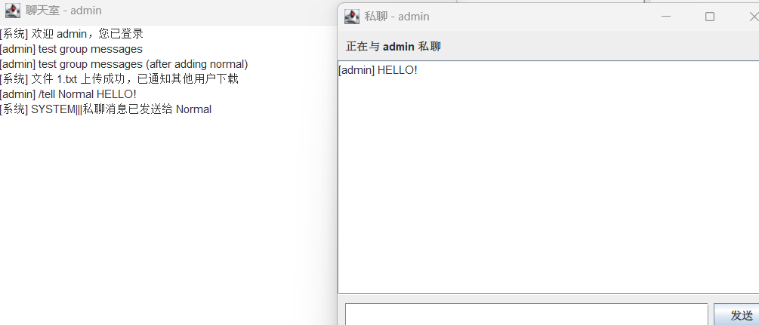

- Test admin commands:

(i). /help to get the command list:
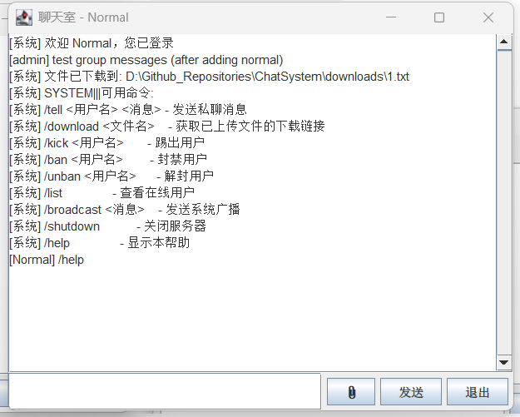

The following commands can only be executed in the administrator account:

(ii). /list to get the online user list:
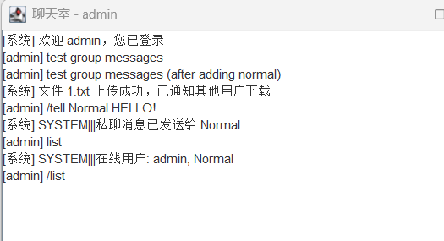
Other normal account who tried to use this command will cause a failure:
e.g. /ban
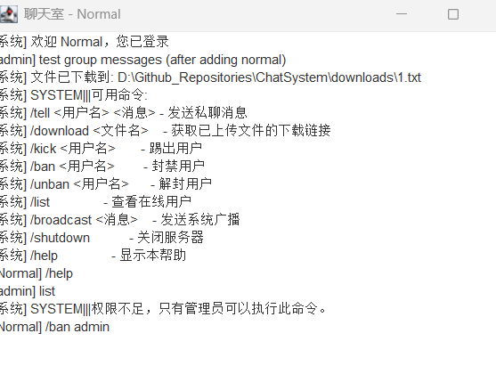

(ii). /kick to kick users:
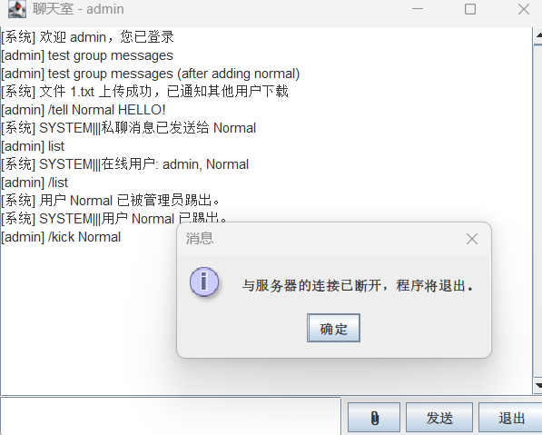

However, we can successfully login “Normal” account again:
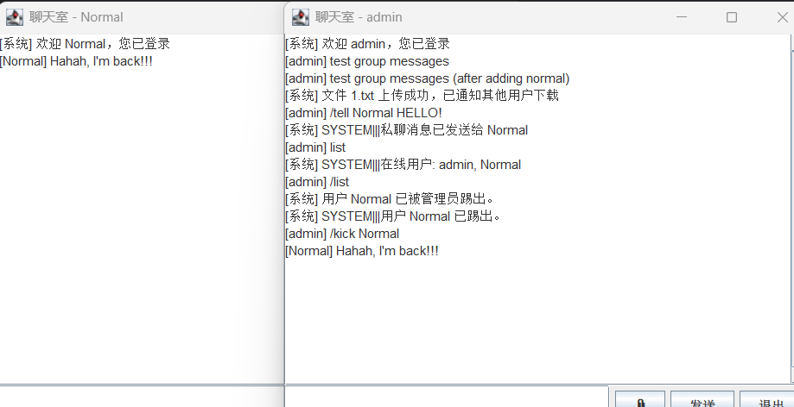

(iii). /ban : if the administrator didn’t want to see this bad guy again, he/she can use the /ban command to ban the guy’s account:
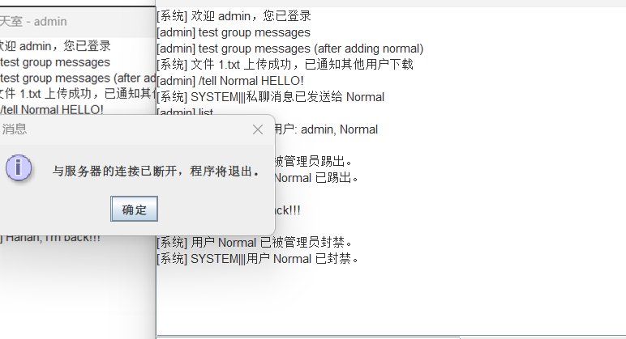

Notice that he can not login now:
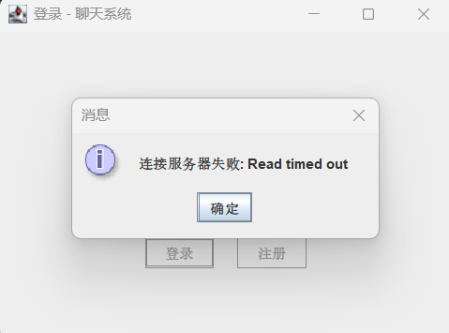

(iv). /unban : if the bad guy realized his fault and becomes a good person, we can use /unban command to unban his account:
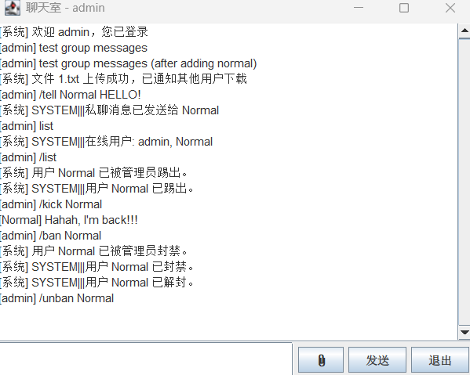
We can login again!
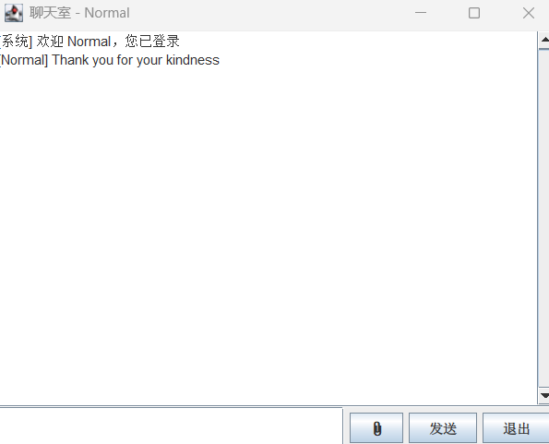

(v). /broadcast :
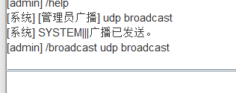

(vi). /shutdown:
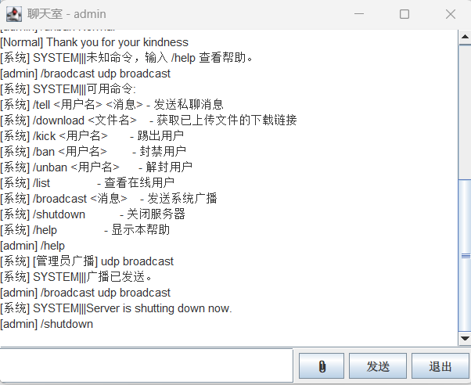

- Logs:
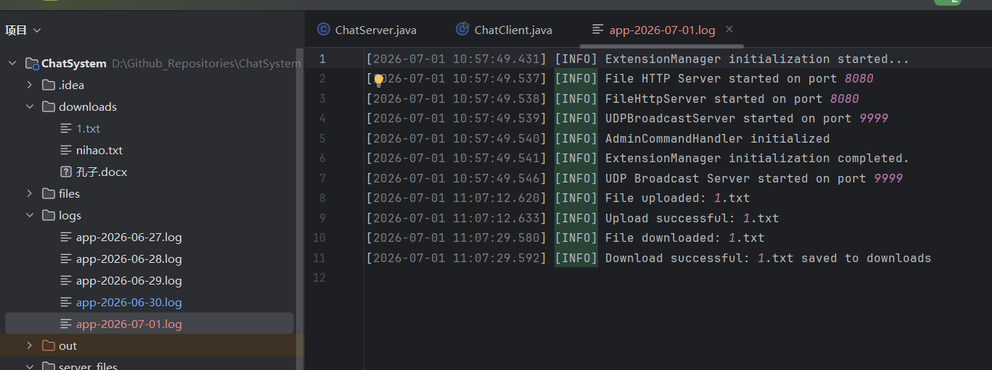
Detailed running logs are stored in the /logs folder.
- users.dat:
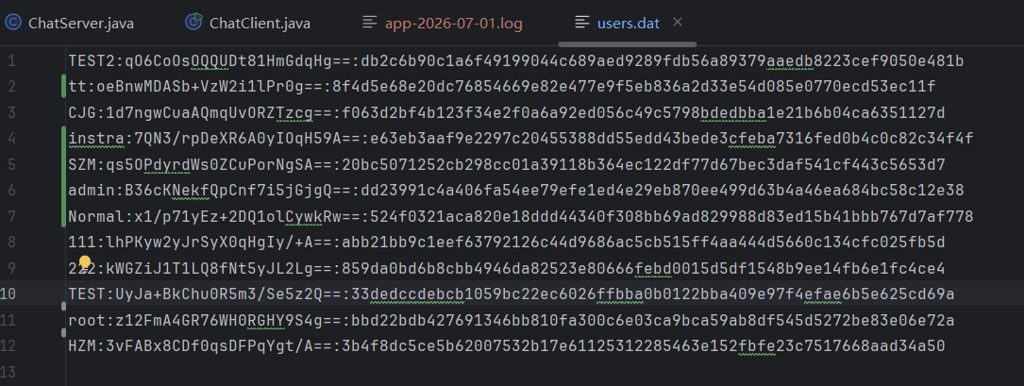
Users’ information is encrypted and stored in users.dat after registration.

Experimental Conclusions
This experiment implements a fully functional multi-user chat system built on the Java NIO and Swing technology stack. The server adopts a Selector multiplexing + thread pool architecture. A single thread efficiently manages massive concurrent connections, eliminating the resource waste of the traditional BIO model that allocates one independent thread for each connection.
The system covers core instant messaging capabilities: persistent TCP connection communication, group and private chat, user registration and login secured by SHA-256 with salt hashing, dual-channel HTTP file transfer, UDP broadcast announcements, administrator commands (user kicking, account banning, global broadcast), and a complete SSL/TLS encryption framework. The logging module records all runtime activities with daily rolling log files. The client supports dual-stack IPv4/IPv6 and DNS hostname resolution.
The overall design decouples I/O threads from business logic threads. Each module features clear responsibilities and excellent scalability, meeting practical requirements for concurrent multi-user chatting.

二、诚信承诺：
本人郑重承诺在该课程论文完成的过程中不发生任何不诚信现象，一切不诚信所导致的后果均由本人承担。
Integrity Commitment:
I/We solemnly promise that I/we have not plagiarized during the completion of this course paper, and all the consequences caused by plagiarism will be borne by me/us.

签名拍照附件:
Name and Digital Signature of all students in the group


Date: July 1st , 2026

